**­­Nested looping**

1. Practice all the class examples of nested loop.
2. Write a program that will check a number whether it is prime or not.
3. Write a program to find out the prime numbers between **2 to n** (take n as upper bound).
4. Write down programs to generate the followings using nesting loops:
5. (b) (c) (d)

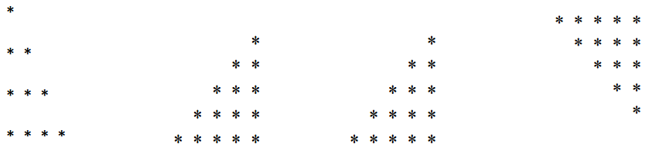

****

****

****

****

(e) (f) (g)

1

2 3

4 5 6

7 8 9 10

11 12 13 14 15

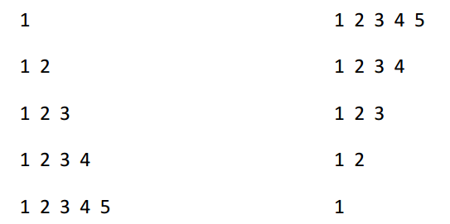

(h)

1

2 2

3 3 3

4 4 4 4